VIRTUAL MOUSE
A Industry oriented project Report Submitted

In partial fulfillment of the requirement for the award of the degree of

Bachelor of Technology
In
Computer Science and Engineering -Artificial Intelligence and Machine Learning

by

C.Radhika-(22N31A6636)

CH.Venkat- (22N31A6638)

CH.Kamala priya-(22N31A6639)

Under the Guidance of
Dr.D.Sujatha
Head of the department
Computational Intelligence Department
MRCET
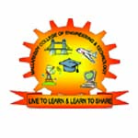
DEPARTMENT OF COMPUTATIONAL INTELLIGENCE
MALLA REDDY COLLEGE OF ENGINEERING AND TECHNOLOGY
(Affiliated to JNTU, Hyderabad)
ACCREDITED by AICTE-NBA
Maisammaguda, Dhulapally post, Secunderabad-500014.

2020-2024

DECLARATION

I hereby declare that the project entitled “virtual mouse” submitted to Malla Reddy College of Engineering and Technology, affiliated to Jawaharlal Nehru Technological University Hyderabad (JNTUH) for the award of the degree of Bachelor of Technology in Computer Science and Engineering- Artificial Intelligence and Machine Learning is a result of original research work done by me.

It is further declared that the project report or any part thereof has not been previously submitted to any University or Institute for the award of degree or diploma.

C.Radhika(22N31A6636)

CH.Venkat(22N31A6638)

CH.Kamala Priya(22N31A6639)



CERTIFICATE

This is to certify that this is the bonafide record of the project titled “title of your project” submitted by C.Radhika(22N31A6636),ch.venkat(22N31A6638),Ch.kamala Priya(22N31A6639) of B.Tech in the partial fulfillment of the requirements for the degree of Bachelor of Technology in Computer Science and Engineering- Artificial Intelligence and Machine Learning, Dept. of CI during the year 2023-2024. The results embodied in this project report have not been submitted to any other university or institute for the award of any degree or diploma.

Dr.D.Sujatha DR.D.Sujatha
Head of the department Professor
INTERNAL GUIDE HEAD OF THE DEPARTMENT

EXTERNAL EXAMINER

ACKNOWLEDGEMENT

We feel honored and privileged to place our warm salutation to our college Malla Reddy College of Engineering and technology (UGC-Autonomous), our Director Dr. VSK Reddy who gave us the opportunity to have experience in engineering and profound technical knowledge.
We are indebted to our Principal Dr. S. Srinivasa Rao for providing us with facilities to do our project and his constant encouragement and moral support which motivated us to move forward with the project.
We would like to express our gratitude to our Head of the Department Dr. D. Sujatha for encouraging us in every aspect of our system development and helping us realize our full potential.
We would like to thank our application development guide as well as our internal guide
Dr.D.Sujatha(Hod), for his structured guidance and never-ending encouragement. We are extremely grateful for valuable suggestions and unflinching co-operation throughout application development work.
We would also like to thank all supporting staff of department of CI and all other departments who have been helpful directly or indirectly in making our application development a success.
We would like to thank our parents and friends who have helped us with their valuable suggestions and support has been very helpful in various phases of the completion of the application development.

By

C.Radhika(22N31A6636)

CH.Venkat(22N31A6638)

CH.Kamala Priya(22N31A6639)

ABSTRACT

- In this project, we are developing a virtual mouse that utilizes hand gesture recognition technology to control the cursor on a computer screen.
- The virtual mouse was developed using Media pipe for hand gesture recognition, computer vision is used for identify and understand objects.
- Media pipe provides pre-trained models for hand landmark detection, hand pose estimation.
- The virtual mouse was able to accurately detect and track hand gestures in real-time. This technology can also be applied in fields such as gaming, virtual reality, and accessibility.

TABLE OF CONTENTS

S.No. Topic Page No.

1: INTRODUCTION-------------------------------------------------------------------7-8
1.1: Purpose----------------------------------------------------------------------------7
1.2: Background of project-----------------------------------------------------------7
1.3: Scope of project------------------------------------------------------------------8
1.4: Project features-------------------------------------------------------------------8
2: SYSTEM REQUIREMENTS-----------------------------------------------------4
2.1 H/W & S/W Requirements------------------------------------------------------4
2.2 Functional Requirements--------------------------------------------------------4
3: TECHNOLOGIES USED---------------------------------------------------------6
3.1 computer vision
3.2 gesture recognisation
4: SYSTEM DESIGN ----------------------------------------------------------------8
4.1: UML Diagrams
5: IMPLEMENTATION -----------------------------------------------------------10
5.1 Source Code
5.2 Output Screens
6: CONCLUSION--------------------------------------------------------------------12

7: REFERENCES----------------------------------------------------------------------

1. INTRODUCTION

1.1 Purpose:

The main purpose of this document is to present the requirements of the project “Phishing detection using Machine Learning algorithms”. This study's goal is to evaluate the effectiveness of several phishing categorization methods using a range of different data sources and approaches. This study compares these strategies' efficiency in correctly recognizing phishing attempts by completing a thorough review. In order to identify the most effective strategies for preventing phishing threats in a variety of scenarios and datasets, the study aims to offer insights into which techniques function best under diverse conditions.

1.2 Background of project:

Phishing is a type of cybercrime when criminals attempt to gain sensitive or private information from consumers by establishing a fake website that seems identical to a legitimate one. Multiple tactics, including link manipulation, filter evasion, website forgery, covert redirect, and social engineering, are used in phishing assaults.
The escalating threat of phishing attacks necessitates effective classification techniques. In addition to this, there is a pressing need to comprehensively evaluate the performance of phishing classification techniques across diverse scenarios, enabling the identification of techniques that yield accurate and consistent results across various data sources and classification schemes.
The existing works based on phishing detection using classification methods are mostly based on heuristic features where feature selection can be extracted from the attributes such as Uniform Resource Locator, Source Code, Session, type of security involve, protocol used, type of website. Limited number of machine learning algorithms have been used to test their model and the metrics used are only regression tasks. The proposed system project assesses the classification methods on dataset through schemes. The ten performance measures are compared and evaluated between the thirteen most recent classification techniques. The proposed system helps users in providing all inclusive views of model performance.

1.3 Scope of project: Think about your regular computer mouse - now imagine it without any physical limitations. Our Virtual Mouse Project uses fancy technology like computer vision and machine learning to create a mouse that doesn't need to be touched or moved physically. It's like magic!
Whether you're a creative person who needs super precise control or someone who might find a regular mouse tricky to use, our Virtual Mouse is designed to make things easier for everyone.
We're not just changing the mouse; we're changing the way you connect with your computer. It's like stepping into the future of how we use technology. So, get ready to say goodbye to the old mouse and hello to a new, improved way of interacting with your computer

1.4 Project Features:

The system features are as follows:
A virtual mouse, which enables users to interact with their computers without a physical mouse, offers various features that enhance its functionality and user experience. Key quality features include:

1. Accuracy and Responsiveness:
- Precise tracking and quick response times ensure smooth and accurate cursor movement.

2. Customizable Sensitivity:
- Adjustable sensitivity settings allow users to tailor the cursor speed and movement according to their preferences.

3. Gesture Recognition:
- Supports various gestures (e.g., pinch, swipe, rotate) for intuitive navigation and control.

4. Compatibility:
- Works seamlessly across different operating systems and applications.

5. User Interface:
- Easy-to-use interface for setting up and configuring the virtual mouse.

6. Accessibility:
- Designed to assist users with physical disabilities by providing alternative input methods.

7. Battery Efficiency:
- Optimized for low power consumption, ensuring long usage times between charges.

2.SYSTEM REQUIREMENTS

2.1 Hardware Requirements: The following describes the hardware needed in order to execute and develop the Virtual Mouse application:
- Minimum Intel i3 processor
- 3 GB RAM
- 5 GB HDD space
- Peripheral webcam at least 30 frames/second, 640x480 resolution

2.2 Software Requirements: The following describes the software needed in-order to develop the Virtual Mouse application:
- Windows 10
- PYTHONCHARM
- OpenCV ,media pipe
- Webcam drivers (device specific)

2.3 Existing System: It is known that there are various types of physical computer mouse in the modern technology, trackball mouse that is commonly used in the 1990s, the ball within the mouse are supported by two rotating rollers in order to detect the movement made by the ball itself.

2.3.1 Drawbacks of existing system:

- one roller detects the forward/backward motion while the other detects the left/right motion. The common functions included are the left/right buttons and a scroll-wheel.
- The existing work consists of limited machine learning algorithms and metrics which are associated with regression tasks.
- This work has less robustness because it does not deal with the diversity of datasets.

- 2.4 Proposed System: the software requires to be fast enough to capture and process every image, in order to successfully track the user's gesture. Therefore, this project will develop a software application with the aid of the latest software coding technique and the open-source computer vision library also known as the OpenCV.
- The process of the application can be started when the user's gesture was captured in real time by the webcam, then we are calling the hands class from mediapipe. This is the class that will help us recognize all 20 geometric points on the hand.
- The software application is compatible with the Windows platform. The functionality of the software will be coded with Python programming language code with the integration of an external library that does the image processing known as the OpenCV.
3. TECHNOLOGIES USED:
- Computer Vision: Computer vision technologies may be employed to track hand movements or gestures using cameras or depth sensors. Machine learning algorithms can interpret these movements to control the virtual mouse cursor.
- Gesture Recognition: Advanced algorithms analyse hand movements and gestures to recognize specific actions, such as pointing, clicking, dragging, and scrolling.

4. SYSTEM DESIGN

4.1 System Architecture
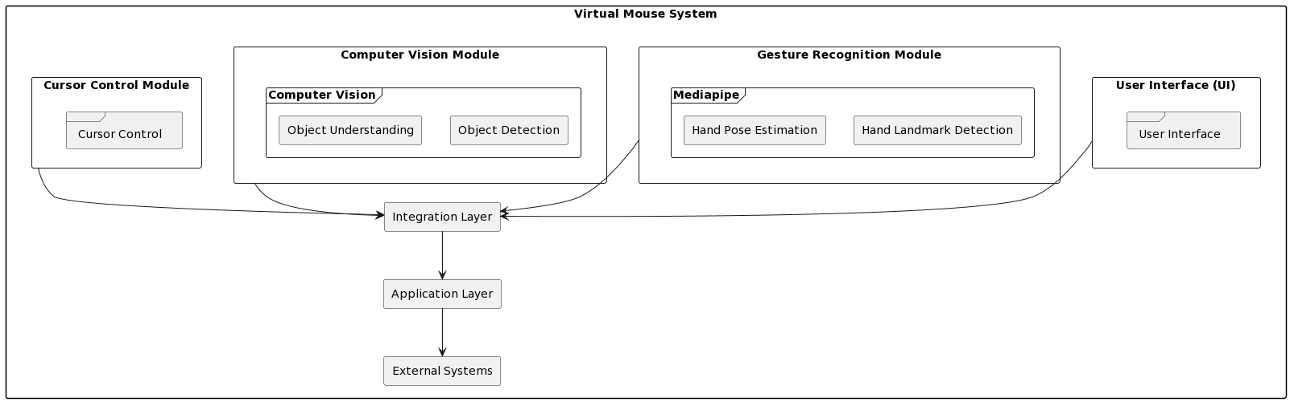
Fig 4.1

4.2 Data flow diagram

DFD represents the data flow of a system or process. It also sheds light on each entity's inputs, outputs, and the process itself. There are no loops, decision rules, or control flows in DFD. A flowchart can describe specific operations depending on the type of data. It is a graphic tool that can be used to communicate with users, supervisors, and other staff members. It can be used to analyze both current and new systems.

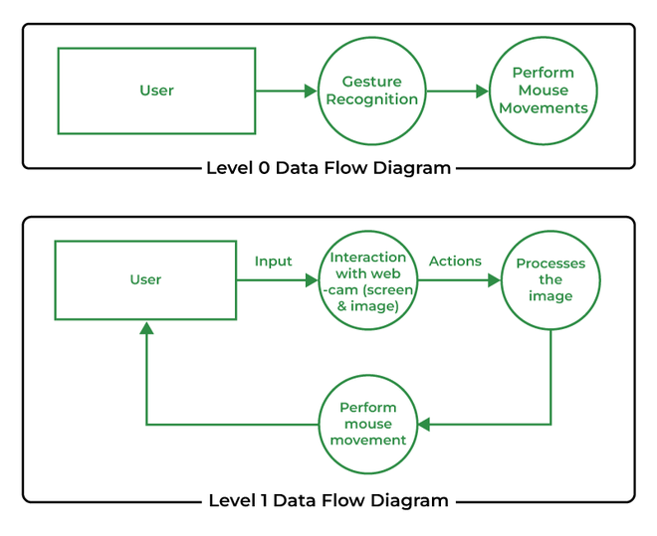

Fig 4.2

4.3 UML Diagrams

4.3.1 Use case diagram

Use Case during requirement elicitation and analysis to represent the functionality of the system. Use case describes a function by the system that yields a visible result for an actor. The identification of actors and use cases result in the definitions of the boundary of the system i.e., differentiating the tasks accomplished by the system and the tasks accomplished by its environment.
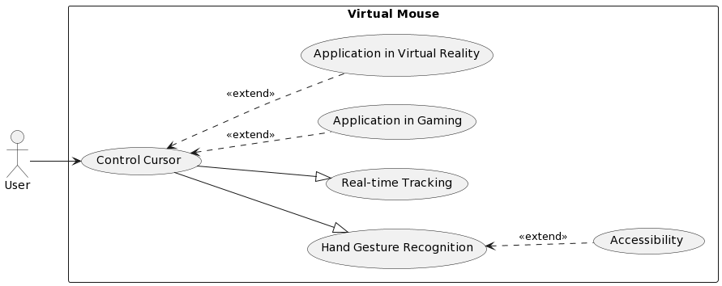
Fig 4.3 (a)

4.3.2 Class Diagram

Class diagrams model class structure and contents using design elements such as classes, packages and objects. Class diagram describe the different perspective when designing a system-conceptual, specification and implementation. Classes are composed of three things: name, attributes, and operations. Class diagram also display relationships such as containment, inheritance, association etc. The association relationship is most common relationship in a class diagram. The association shows the relationship between instances of classes.
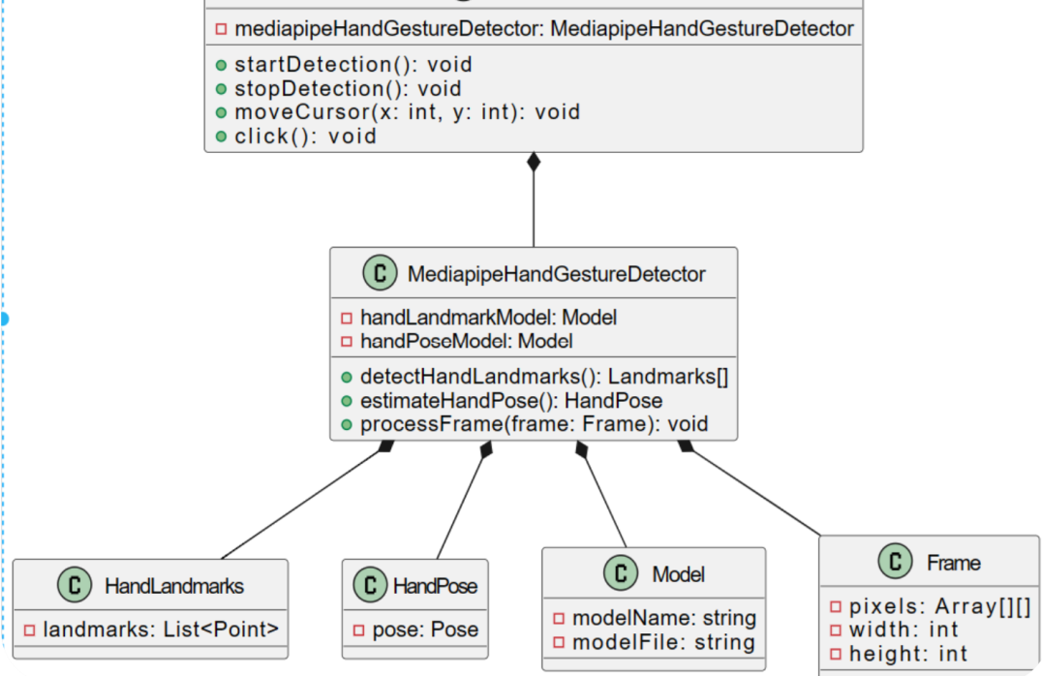
Fig 4.3 (b)

4.3.3 Sequence Diagram

Sequence diagram displays the time sequence of the objects participating in the interaction. This consists of the vertical dimension (time) and horizontal dimension (different objects).
Objects: An object can be thought of as an entity that exists at a specified time and has a definite value, as well as a holder of identity. A sequence diagram depicts item interactions in chronological order. It illustrates the scenario's objects and classes, as well as the sequence of messages sent between them in order to carry out the scenario's functionality. In the Logical View of the system under development, sequence diagrams are often related with use case realizations. Event diagrams and event scenarios are other names for sequence diagrams. A sequence diagram depicts multiple processes or things that exist simultaneously as parallel vertical lines (lifelines), and the messages passed between them as horizontal arrows, in the order in which they occur. This enables for the graphical specification of simple runtime scenarios.

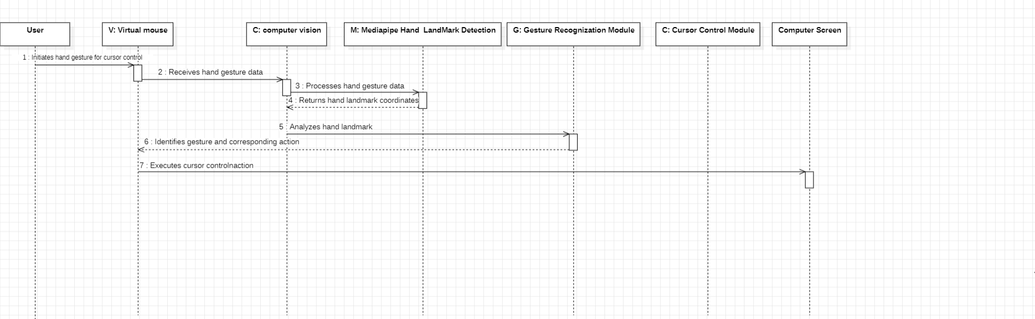
:System
Fig 4.3 (c)

4.3.4 Activity Diagram

The process flows in the system are captured in the activity diagram. Similar to a state diagram, an activity diagram also consists of activities, actions, transitions, initial and final states, and guard conditions.

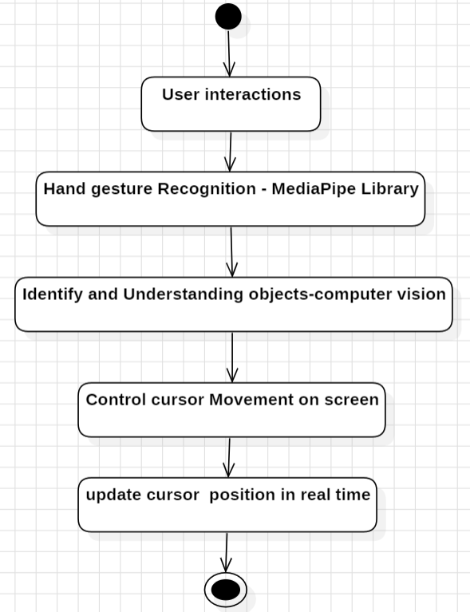

Fig 4.3 (d)

5.IMPLEMENTATION

5.1: Code:
import cv2
import mediapipe as mp
import pyautogui
cap = cv2.VideoCapture(0)
hand_detector = mp.solutions.hands.Hands()
drawing_utils = mp.solutions.drawing_utils
screen_width, screen_height = pyautogui. size ()
index_y = 0
while True:
_, frame = cap.read()
frame = cv2.flip(frame, 1)
frame_height, frame_width, _ = frame.shape
rgb_frame = cv2.cvtColor(frame, cv2.COLOR_BGR2RGB)
output = hand_detector.process(rgb_frame)
hands = output.multi_hand_landmarks
if hands:
for hand in hands:
drawing_utils.draw_landmarks(frame, hand)
landmarks = hand.landmark
for id, landmark in enumerate(landmarks):
x = int(landmark.x*frame_width)
y = int(landmark.y*frame_height)
if id == 8:
cv2.circle(img=frame, center=(x,y), radius=10, color=(0, 255, 255))
index_x = screen_width/frame_width*x
index_y = screen_height/frame_height*y

if id == 4:
cv2.circle(img=frame, center=(x,y), radius=10, color=(0, 255, 255))
thumb_x = screen_width/frame_width*x
thumb_y = screen_height/frame_height*y
print('outside', abs(index_y - thumb_y))
if abs(index_y - thumb_y) < 20:
pyautogui.click()
pyautogui.sleep(1)
elif abs(index_y - thumb_y) < 100:
pyautogui.moveTo(index_x, index_y)
cv2.imshow('Virtual Mouse', frame)
cv2.waitKey(1)

5.2: Output Screens:

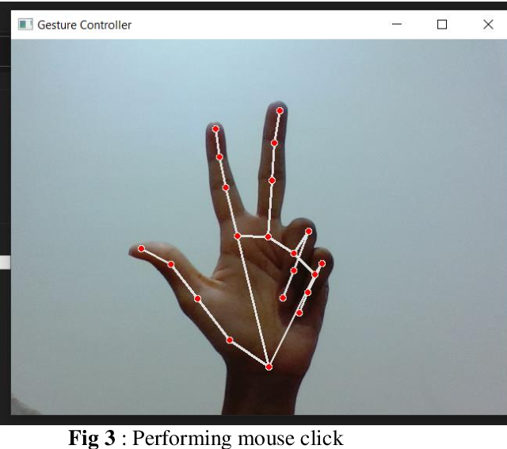

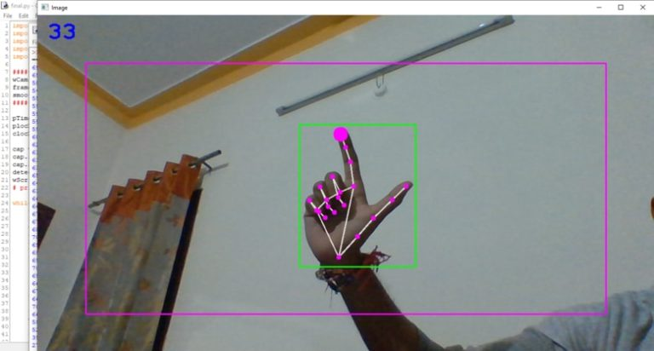

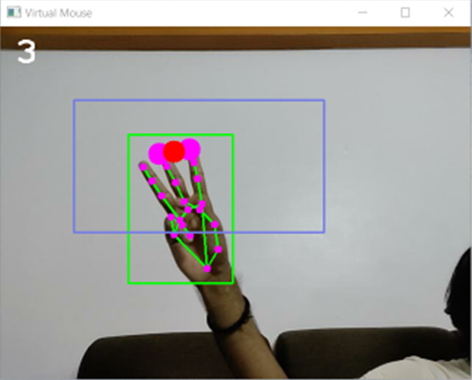

5.3: Testing

Software testing is a critical element of software quality assurance and represents the ultimate review of specification, design and code generation.

6. CONCLUSION & FUTURE SCOPE

- The "Virtual Mouse Using Hand Gestures Recognition" project aims to provide a new and intuitive way of controlling a computer using hand gestures.
- The combination of Computer Vision, Media pipe provides efficient solution for building and PyCharm for executing the virtual mouse.
- Media pipe’s hand landmark and gesture recognition capability has been shown to perform well in real-world applications and is a popular choice among researchers and developers in the field.
- Overall, the "Virtual Mouse Using Hand Gestures Recognition" project is a promising and innovative solution for controlling a computer using hand gestures. It has the potential to change the way we interact with computers and make computing more accessible for all.

7. BIBLIOGRAPHY

1. IEEE Xplore Digital Library:
- Website: [IEEE Xplore](https://ieeexplore.ieee.org/)
- Description: A digital library for research articles and conference papers in electrical engineering, computer science, and electronics.

2. Google Scholar:
- Website: [Google Scholar](https://scholar.google.com/)
- Description: A freely accessible web search engine that indexes scholarly articles across various disciplines.

3. Gesture Controlled Mouse Using Arduino and Python:
- Platform: Hackster.io
- Summary: A project tutorial that combines Arduino and Python to create a gesture-controlled mouse.

